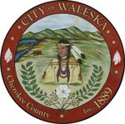
Agenda
City of Waleska
Regular Meeting of the Mayor and Council
January 4, 2020
6:30 p.m.

Item 1: Call to Order

Item 2: Pledge to the Flag

Item 3: Review and Approval of Minutes from December 7, 2020 Meeting

Item 4: Consideration to Approve the Call for an Election, and to Approve Resolution
2021-01 for Election

Item 5: Water System Report

Item 6: City Manager’s Report

Item 7: City Attorney’s Report

Item 8: Mayor’s Report

Item 9: Council Remarks

Item 10: Adjourn Regular Council Meeting

PLEASE NOTE THAT WE WILL BE SOCIAL DISTANCING AT OUR COUNCIL MEETINGS

